**RED DEAD REDEMPTION**

Đoàn Minh Khánh - D19M02

Vũ Quốc Khánh - D19M02

Huỳnh Đức Huy - D19M02

Game Design Document

Version 1.0

**TABLE OF CONTENTS**

I. THE STORY 3

II. CONTROL MECHANISM 4

III. TECHNICAL REQUIREMENTS 10

1. Physicality 10

2. Level of Play 10

3. Play scenario 11

4. Cheating while playing 11

IV. LOGO GAME 12

V. START SCREEN 13

1. Loading game 13

VI. GAME FLOWCHART 15

VII. LOADING SCREEN 16

VIII. GAME CAMERA 16

IX. HUD SYSTEM 17

X. PLAYER METRICS 22

XI. PLAYER SKILLS 23

XII. PLAYER INVENTORY TOOLS 24

XIII. HEALTH 28

1. Display HUD 28

2. Blood and energy supplements 28

3. Warning 29

XIV. VEHICLES 29

XV. MAJOR CHARACTER IN STORY 30

XVI. GAME LEVEL 30

XVII. GAME PROGRESSION OUTLINE 31

XVIII. HỆ THỐNG NHIỆM VỤ 32

XIX. GENERAL ENEMY RULES 33

1. Monsters 33

1.1. Description 33

XX. BOSS 38

1. Description 38

2. Ability 38

3. How to destroy 38

XXI. NPC 38

1. Description 38

XXII. COLLECTIBLES/OBJECTS SETS 40

XXIII. MUSIC AND SFX 40

# THE STORY

The game's plot is contrary to the romantic visions of a free West, the Red Dead Redemption storyline is much darker with a lot of death scenes. It began in 1899, when the Dutch-led Van der Linde gang was on the run to escape the U.S. government's pursuit, because they had just made a huge incident in the city of Blackwater.Dutch led his men to the northern mountains to try to escape and wait for things to settle down. The game begins in the snowy mountains of Colter, the gang is hiding after the events of the Blackwater Massacre, with Dutch van der Linde and his right-hand man, Hosea Matthews, desperately trying to keep their gang free.

From here, the player will play arthur as a member of this gang, who is a powerful dutch arm supporting the gang through many missions. The gang faces a different gang with a similar way of operating, having to carry out countless robberies of the rich in order to dream of the future the gang will be free for a small amount of money. But after many times fleeing the search of the investigating state, fleeing through many areas such as Horsehoe Overlook, the town of Rhodes, the city of Saint Denis ... Later, Dutch encroached deeper into the path of looting, degenerated with robberies and always said this was the last mission. Arthur was losing more and more faith in Dutch and there was a problem within the group. The last mission is when Arthur dies to relieve Jonh, from which the gang disbands Dutch and Micah is a member of the runaway group. And the journey ends from here. Internet and wireless features: when there is no internet, players will be able to play and explore the plot.

Gameplay Red Dead Redemption 2 is a western action-adventure game set in an open world environment and played from a third-person perspective, featuring single-player and online multiplayer components. The game has new features absent from the previous game.

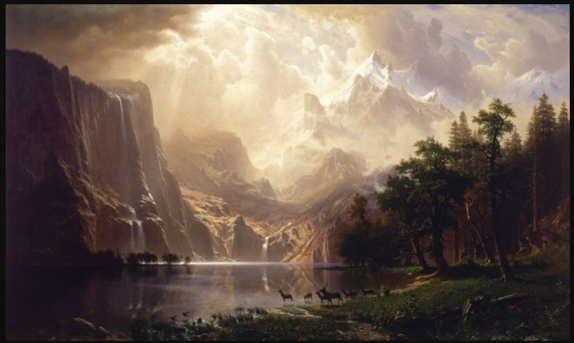

# CONTROL MECHANISM

With the mechanism of controlling the character from the third angle of view moving back and forth using the keyboard and mouse. The process of fighting, shooting, the use of knives and other weapons ... Combined with the perspective graphics make it easy for the user to control the character beyond the assigned tasks and explore the plot.

* In-game controls:

Hit (hit with a pictured weapon with a knife etc. The user clicks the left mouse to control the character).

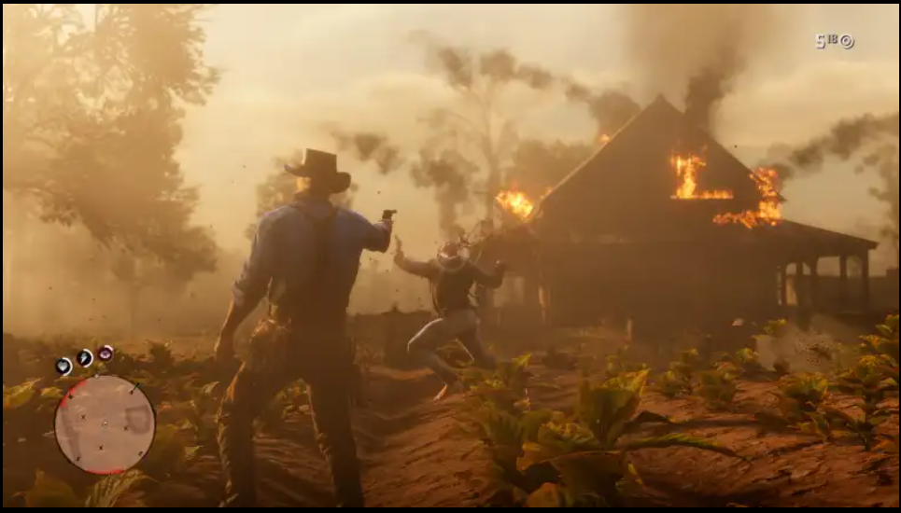

* Energy cells (players pay attention to three points of blood, fitness, dead eye)

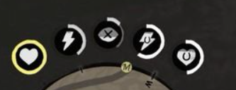

* Aim the gun (the user right-clicks to aim the gun)

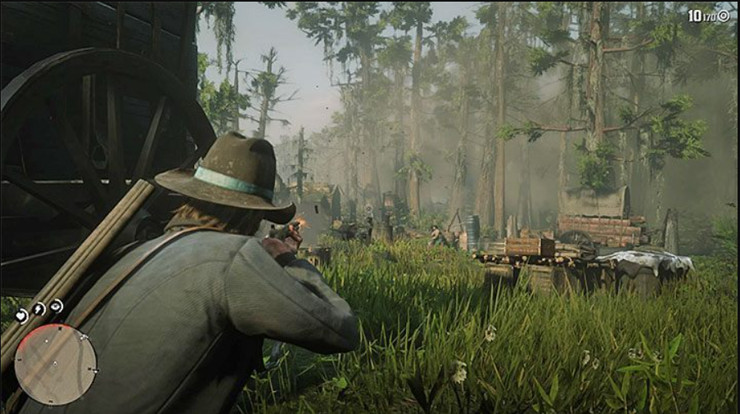

* Bending over (users click control to perform the end of the person)

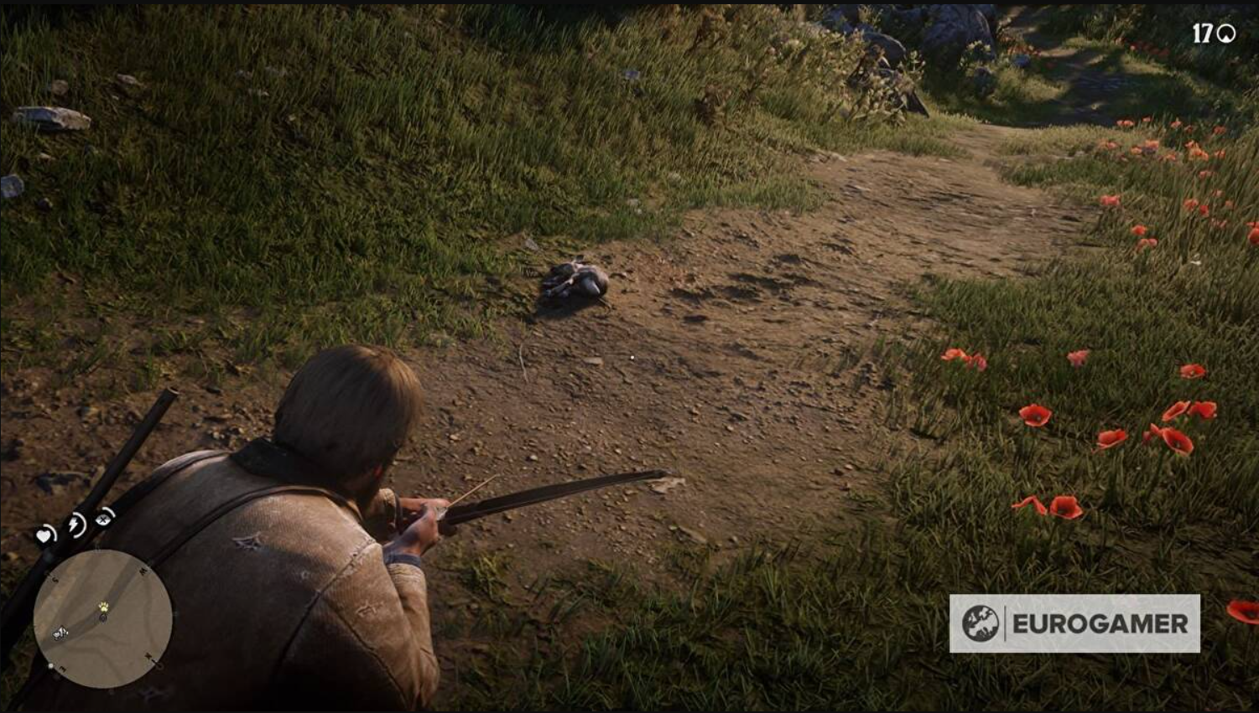

* Horseback riding (users click H to ride horses and click shift to run fast)

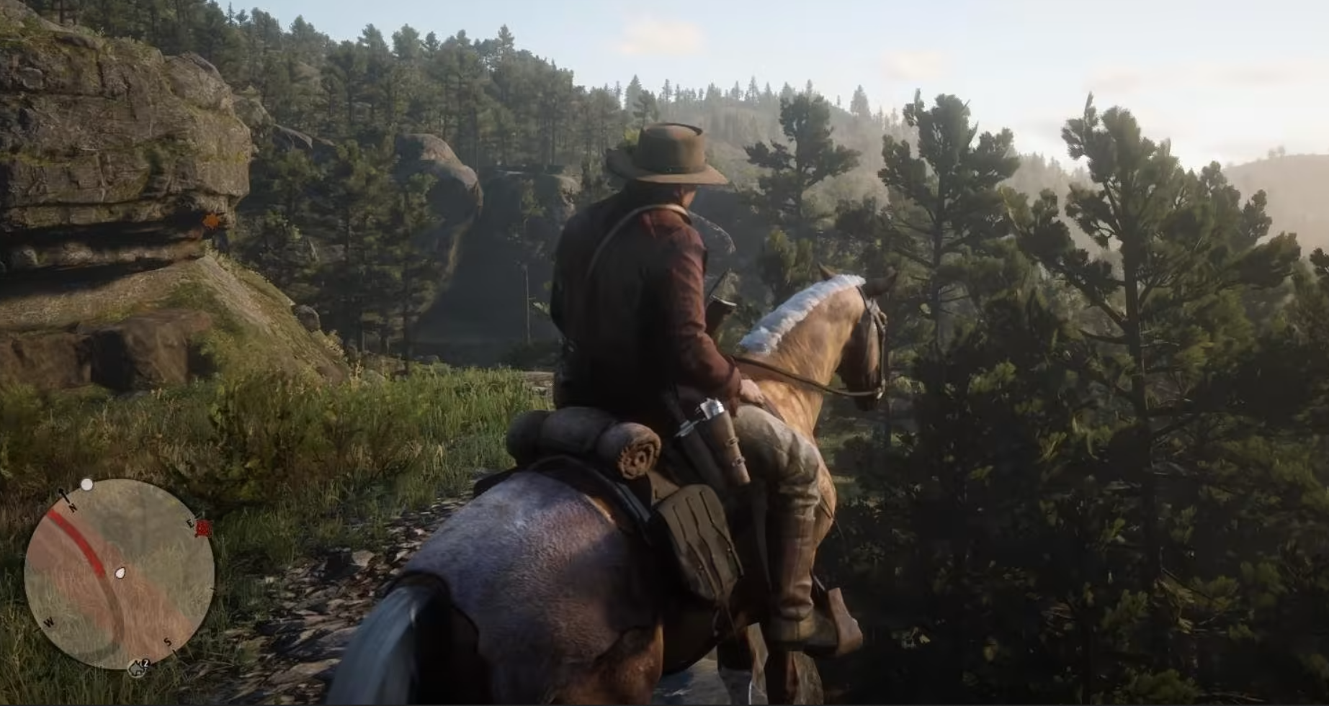

In addition, the player can control the character to run fast, interact with the NPC ...

The area on the map can allow the user to mark the points for the next time to visit again. Large places can display city names etc.

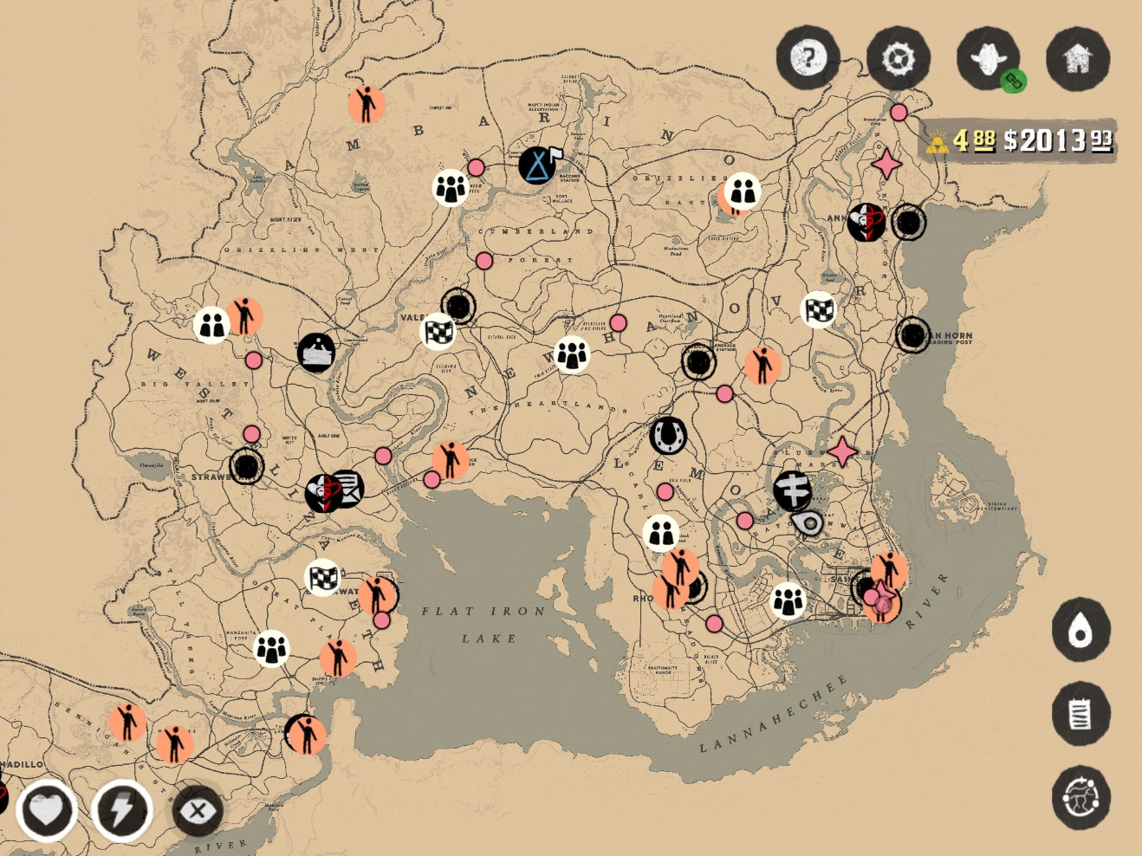

* Food can be blood coughing char
* Alcohol can increase the fitness of the player.

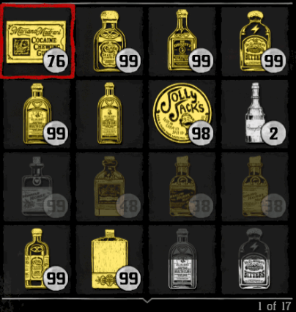

* Click Tab to show the backpack containing the item in the game

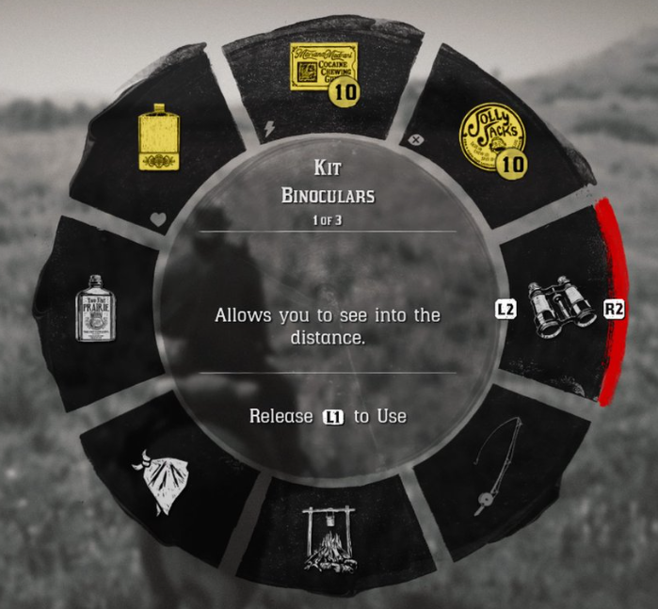

* The minimap will show up in the left corner of the screen.

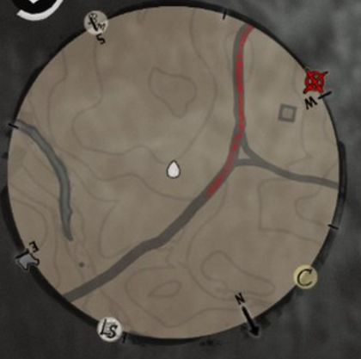

# TECHNICAL REQUIREMENTS

## Physicality

The physics in the game is generally shown when the character flies up or jumps and falls, when the character runs and stops.

The physics in the game in particular is shown through different levels, because each character level will fight in each different terrain. For example, when the character fights where there is water, it will be difficult to move, it will be difficult to be slippery or when the character is in the domestic level, when moving will be subject to the resistance of water, so the move will also be slower than the levels on land.

## Level of Play

The levels are divided according to the tasks assigned by the system to the player that promise to lead the player to experience the open world. Fight other gangs on missions.

Includes many missions leading players to experience the entire plot, graphics, in addition to being able to hunt animals in the wild, cook,...

## Play scenario

New to play, you will be able to control Arthur's character by default and experience the story in the game. In addition, the character in the game will have blood index, physical loss in environmental conditions, hunger, .. This causes the player to go for food and drink water to ensure fitness.

The NPC will have tasks that the player will have to perform and the events in the game. Through these events will in turn lead the player to experience the story.

Through the missions, players will have the opportunity to receive money often players will use this money to buy guns, buy weapons. Upgrading kite weapons causes a bigger problem than conventional weapons.

In addition to the plot level, players can play solo shooting 1v1 pistols, cowboy-style gunfights.

## Cheating while playing

When full of blood and full energy, even if you use more food or new energy, it does not increase.

# LOGO GAME

Manufacturer: HKK-TEAM

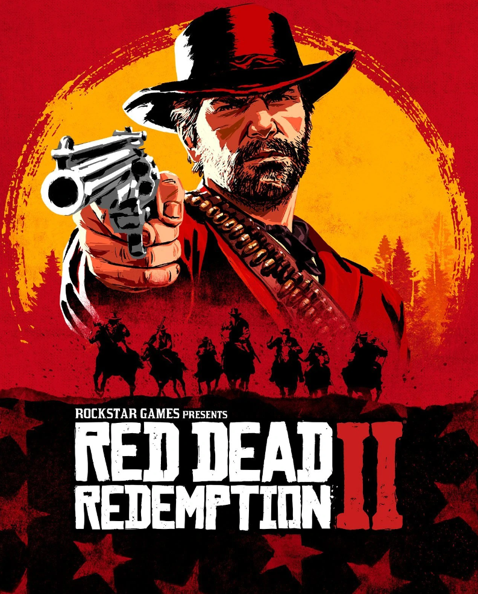

# START SCREEN

## Loading game

Khi the player who selects to enter the game will show the start screen of the game. The game start screen has a loading interface then goes straight into the game.

Game start screen:

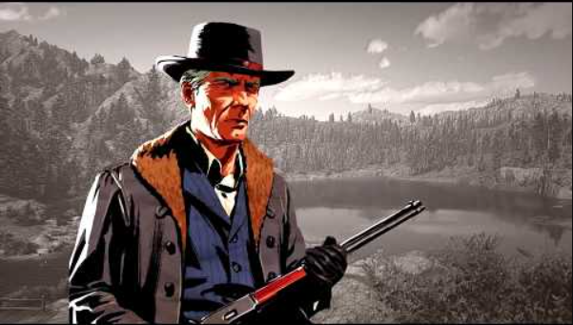

When the player selects the play button, the game will bring the character to the place where the game was last exited.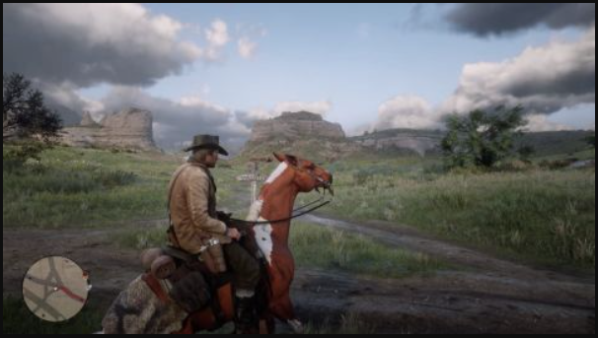

To begin his adventure journey, players can ride horses to explore the world, arrive at the place where the NPC is located and interact with them then take on the mission. Perform the task to receive money.

In addition, users can interact with multiple npcs creating many random cases. For example, saving the injured NPC...

-        The character you can choose when entering the game:

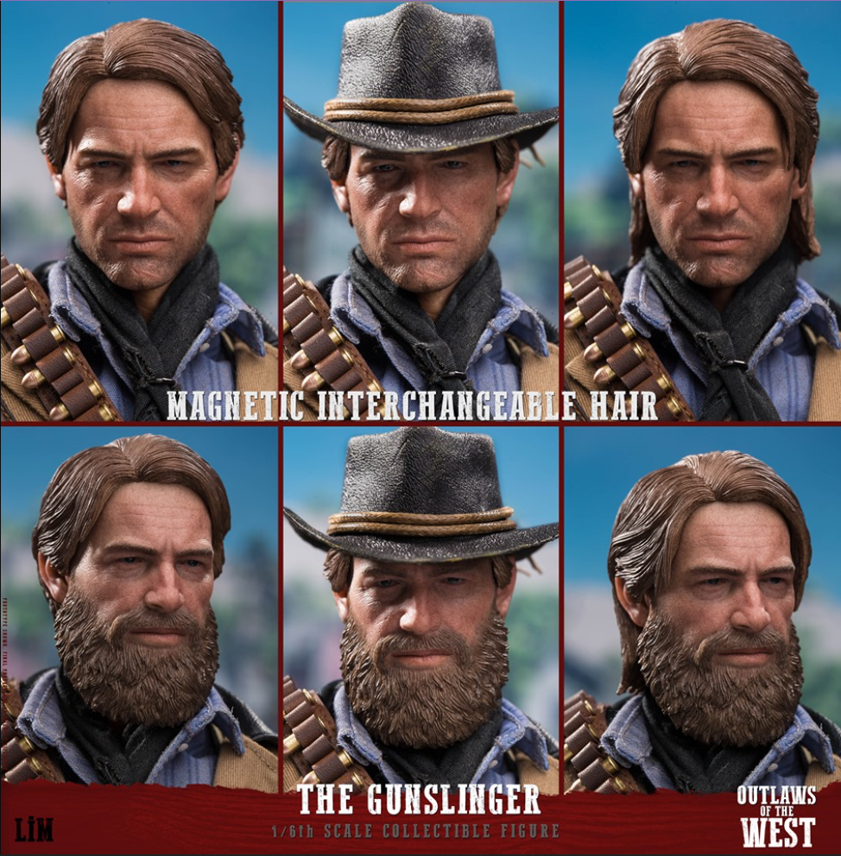

Draft game diagram: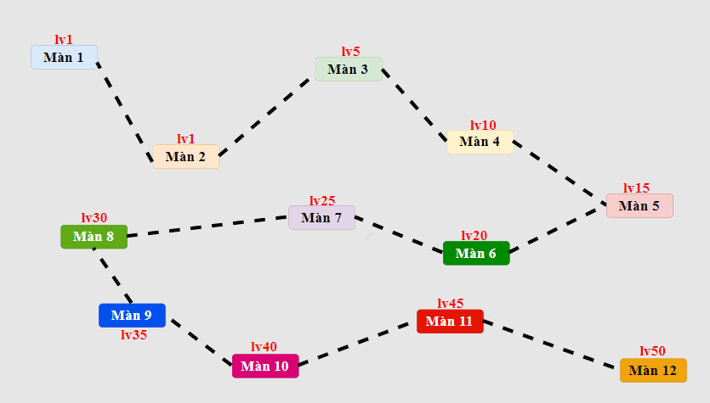

# GAME FLOWCHART

Players after doing all the missions can have a lot of money then choose to buy weapons, food, costumes, upgrade horses, upgrade weapons ... Through many missions, players can both experience the plot and upgrade weapons.

# LOADING SCREEN

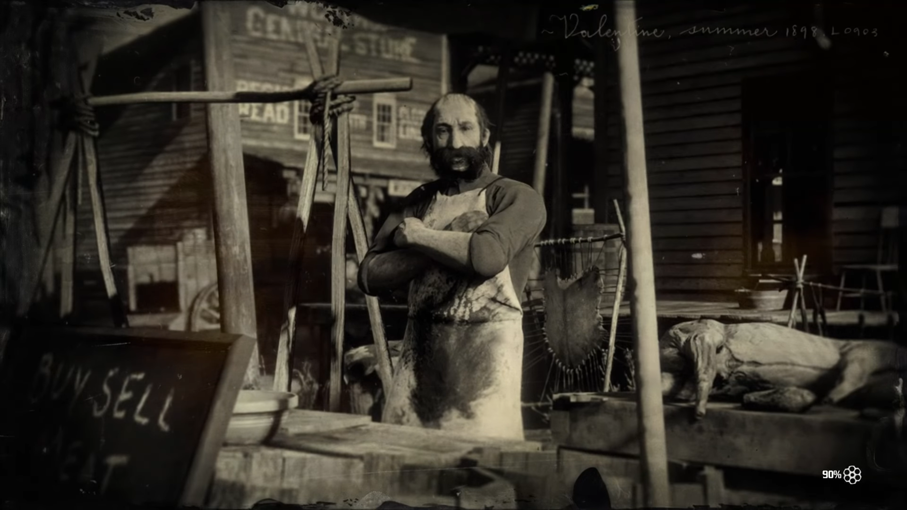While the game is loading, there will be a pause screen, this screen has movement. The screen with the game image in the middle shows the load bar just below the screen.

# GAME CAMERA

Third person camera

With this perspective, players can easily observe the surrounding context to come up with avoidance tactics, provide timely handling as well as use appropriate weapons to be able to overcome the enemies and obstacles in front of them..

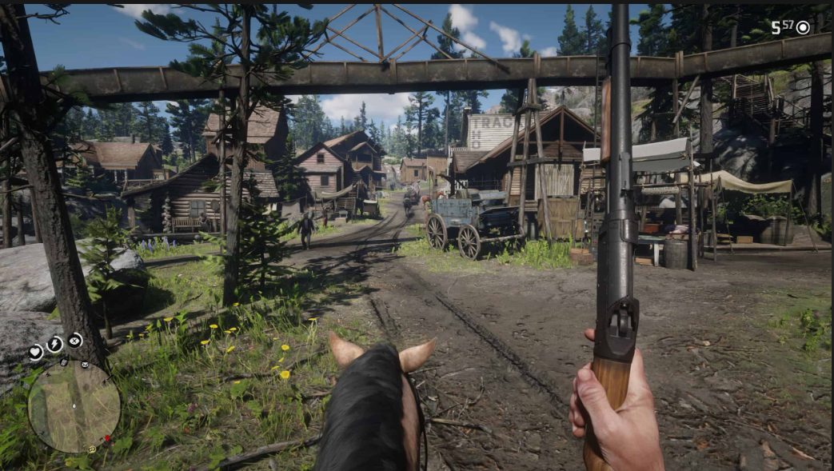

# HUD SYSTEM

The information presented on the screen includes: Player's name, heart-shaped yellow blood bar and energy bar, basket of items the player buys, the number of bad diamonds, the number of diamonds that the player is obtaining, option buttons, pause buttons, character movement buttons, move buttons.

 Heart-shaped blood bar and lightning-shaped energy bar: at the start of the game, the player will have 100% blood and 100% internal strength.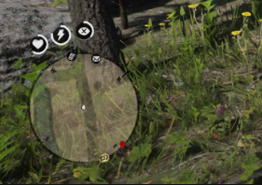

* The basket contains items that the player buys and collects during the game. At the beginning, in the chest there will be 10 food and wine, money, diamonds. The chest will be silvery-white when clicked, which will show the information of the existing currency and diamond items..

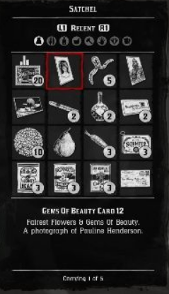

* After you select the basket, you will pore over the following board. The right corner contains items if you want to see item details, then click the information item that will show the right side. Also in the basket shows the number of bad diamonds and diamonds left over. If you want to turn off the cart just click the x button in the upper right corner of the screen.

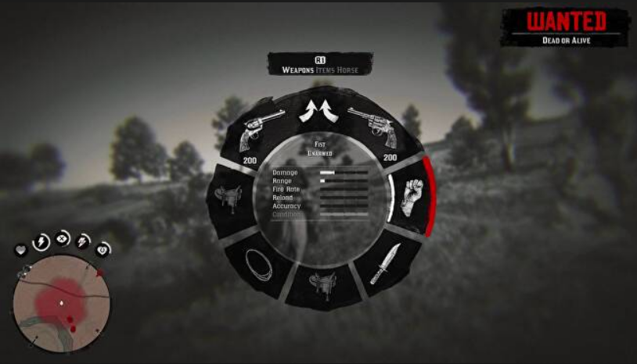

Currencies, diamonds:

The way to earn bad needles is to complete many tasks in the system and will be rewarded with gold coins according to the difficulty.

The amount shown next to the currency symbol is the amount of gold or gold that the player has, gold can be converted into money, 1 gold nugget worth $ 400 players can search for gold in the map and convert it into money.



When players want to convert gold for money, they can reach the npc on the map and can sell gold to these objects.

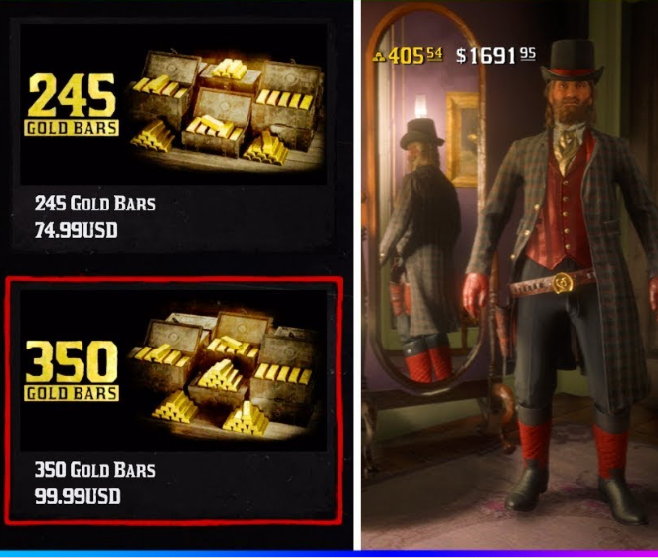

Pause game will display the option screen showing information such as Map, Help, Process ...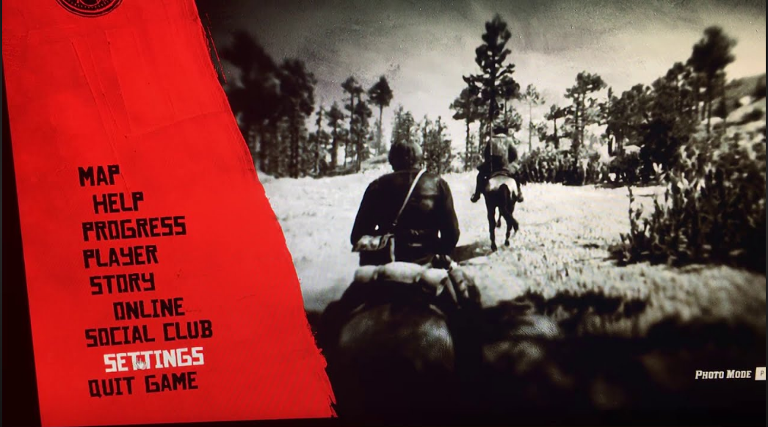

* + The buttons to move the character: fly up, go forward, back you can do 2 operations at the same time that is press the fast button.
  + Skill-performing buttons: press the left mouse ferociously to turn on the slow rotation then perform the enemy shot

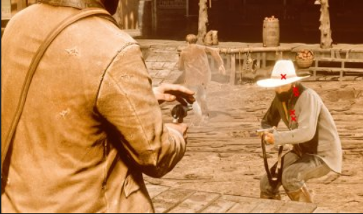

* Recovery: When your blood or energy is less than 100%, it will be used. Each food will recover 20% of the blood or energy.

# PLAYER METRICS

* The size of the player and the monster will depend on the weak strength of the monster, in addition to the animal, there are legendary animals, the size will be very large and bring high value.
* Animal size

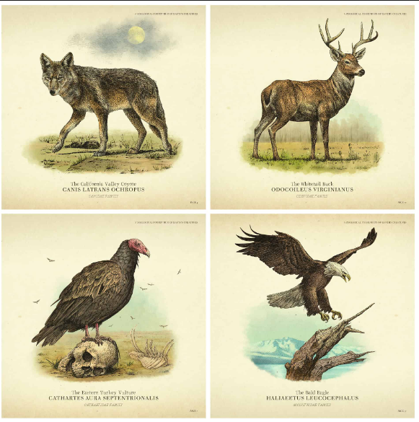

 The size of the person compared to the boss.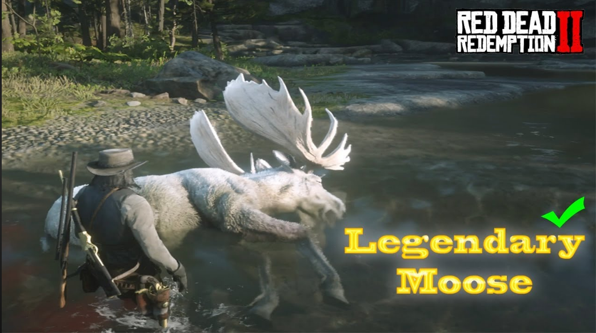

The player can go back and forth up the fast track, ride horses from a third perspective, explore the world..

# PLAYER SKILLS

At the beginning of the game, players will also be given 100% blood and 100% energy. 1 simple weapon (rifle) and 1 rope, 1 dagger, camping suit, explosives, pistol ...

·       Weapon:

Weapon : Depending on the type of weapon, it will help the character increase the attack power and the target quickly die. Specifically, when you first enter the game, you will be given a rifle with an average damage, after having a lot of money will level up many levels to increase the damage level.

·       Moves:

The player will have a skill called dead eye, which helps players prepare well before shooting, then shoot at high speed.

In addition, the game also has a system of character parameters such as blood level, energy level, dead eye level will increase.

# PLAYER INVENTORY TOOLS

To buy weapons, skills, mission personnel, pay the task you need to go to the NPC.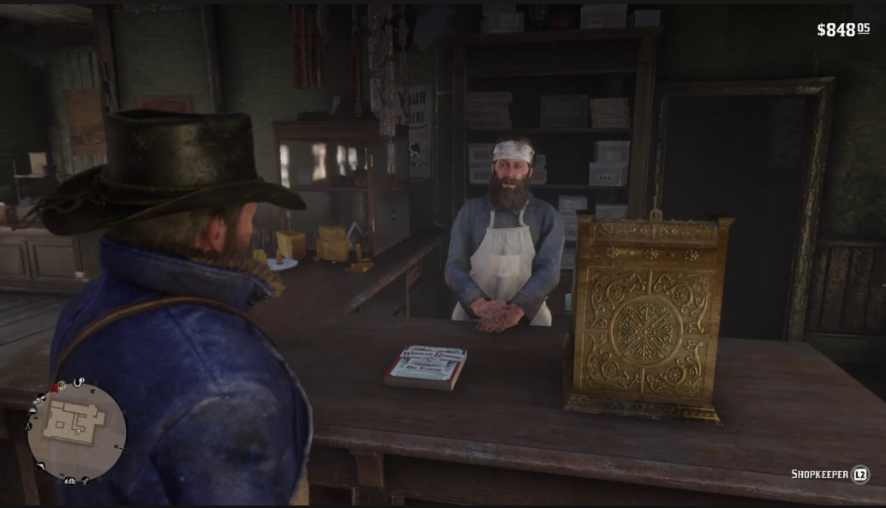

When meeting npc on the map, players can choose a variety of services depending on the function of the npc.  
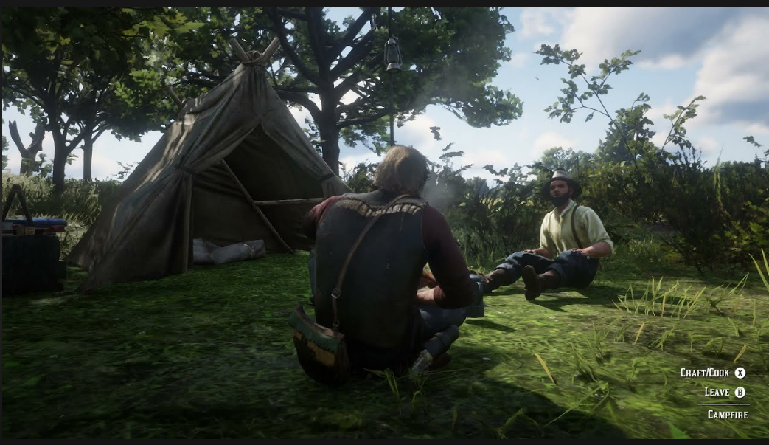

When you complete the task, the npc will come out to thank you and tell their story.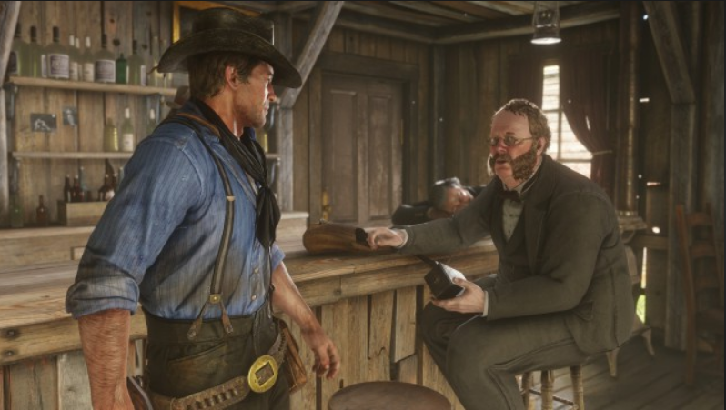

When you choose the store function there will be many of the goods selling alcohol, meat ...

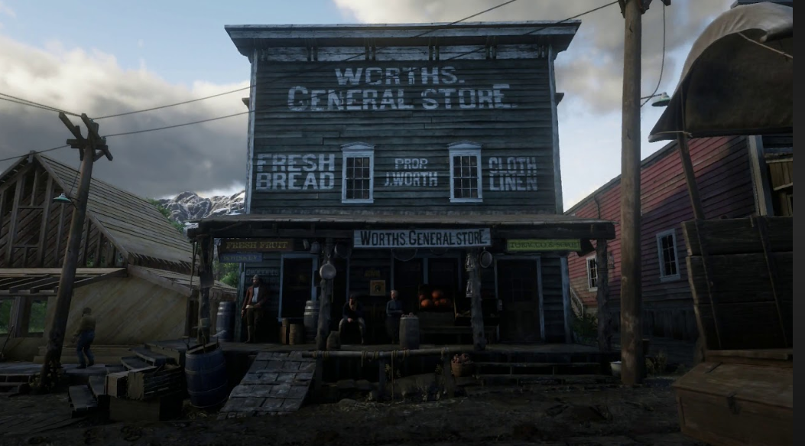

* Weapons of various types are divided.
* Carbine Repeater: A reliable and popular repeating rifle, the Buck Carbine provides medium damage and a decent firing rate, with quick reload speeds thanks to the tube-loaded magazine in the weapon's stock. A good, balanced choice for hunting and medium-range combat, this gun has an ammo capacity of seven rounds, and can use Regular, High Velocity, Split Point, Express and Explosive repeater ammo

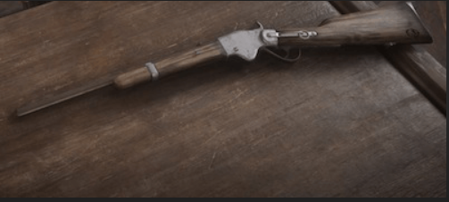

* Repeating Shotgun: The Lancaster Repeating Shotgun is a well-rounded gun that uses the same lever-action system commonly found on repeating rifles. The large ammo capacity gives the shooter the luxury of accuracy while maintaining the power ideal for close-quarter encounters. This gun has an ammo capacity of six rounds, and can use Regular Buckshot, Incendiary Buckshot, Slug and Explosive Slug shotgun ammo.

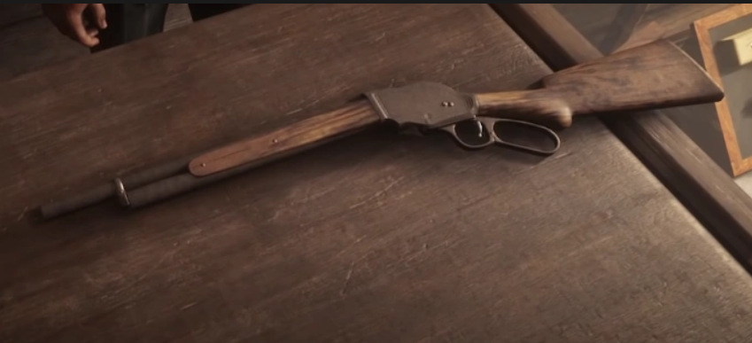

* Wide-Blade Knife: A rare hunting knife with a wide clip-point blade and worn curved wooden handle. This knife was found sticking out of the back of a corpse deep in the mines of Beryl's Dream, Big Valley. The previous owner of this weapon went to great lengths to prevent their crime from being discovered.

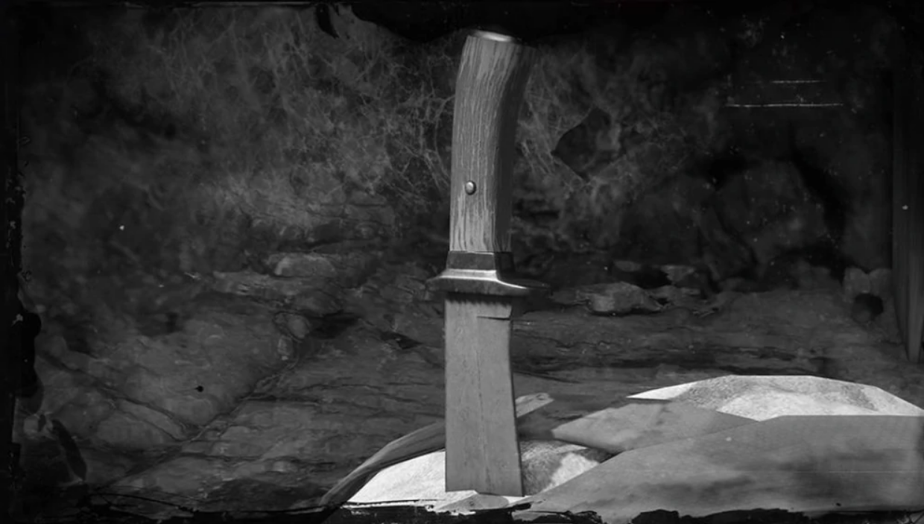

* LeMat Revolver: The LeMat is a cap and ball revolver with a single-shot, smooth bore barrel of buckshot beneath the main barrel, allowing players to switch between revolver and shotgun ammunition at their leisure.

\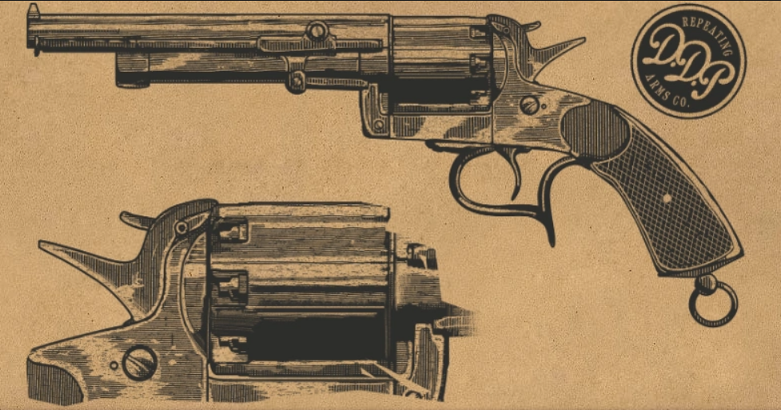

* Coffee Moderately restores Stamina Core and Dead Eye Core
* Minty Crustacean Crustacean Meat x1 Wild Mint x1 Greatly restores Health Core, moderately restores Stamina Core and Dead Eye Core
* Minty Exotic Bird Exotic Bird Meat x1 Wild Mint x1 Fully restores Health Core, greatly restores Stamina Core and Dead Eye Core…

# HEALTH

## Hiển thị HUD

·       The heart (blood) located in the bottom right corner of the screen signifies the survival of the playing character.

-        The player will have 100% blood.

-        When there is 0% blood, the player has really lost and left the level to return to the place of duty.

-        When attacked by monsters, it will depend on quite a lot of factors based on the body to reduce certain amounts of blood.

-        You can use food to increase this blood level to the maximum.

·       The lightning-shaped cell bar (energy) located in the lower left corner of the screen under the red bar signifies the health and fitness of the playing character.

-        The player will have 100% energy.

-        A normal targeting reduces the internal force by 0.5%, the more advanced the weapon needs to be used.

-        Depending on the type of skill used, the energy will be consumed from 5-60%. The longer the dead eye skill, the more it will cost.

-        Internal strength of 50% or more, all the moves and weapons that the player has.

-        When the internal force is only 0%, the character can only run forward, backward, unable to fly.

## Bổ sung máu và năng lượng

·       Blood:

-        Each food will provide a certain amount of blood for the large meat character that will provide the most.

-        Each normal food will recover 20% of the blood in 1 second and have a effect of 3 seconds.

-        Once 100% blood has been restored and the player still receives more gas cylinders, it is still not increased further.

-        You can also use cooked food that will heal more blood for the character.

·       Energy:

-        The energy bar will automatically decrease: 30s reduces internal strength by 2%. It is very slow so the player needs to find more internal strength for himself.

-        Each power tank gives 20% of the character's energy.

-        Each power tank will restore 20% of the energy in 1 second and have a 3-second effect.

-        Once 100% recovered and the player still receives more internal forces, there is still no further internal strength.

-        You can also use tobacco alcohol to increase your fitness.

## Warning

When the player's blood and energy bar remains 20%, the game begins to warn the player by: for the end of internal strength, the player's character will emit a blue light, both bright and flashing. As the blood runs out, the player's character will emit a red light, which is also bright and flashing. If the character of the player dies the player will return to the old level.

# VEHICLES

Horse: will be a means of transportation in the game, when the character needs transportation, will whistle this will bring the horse if the horse is nearby.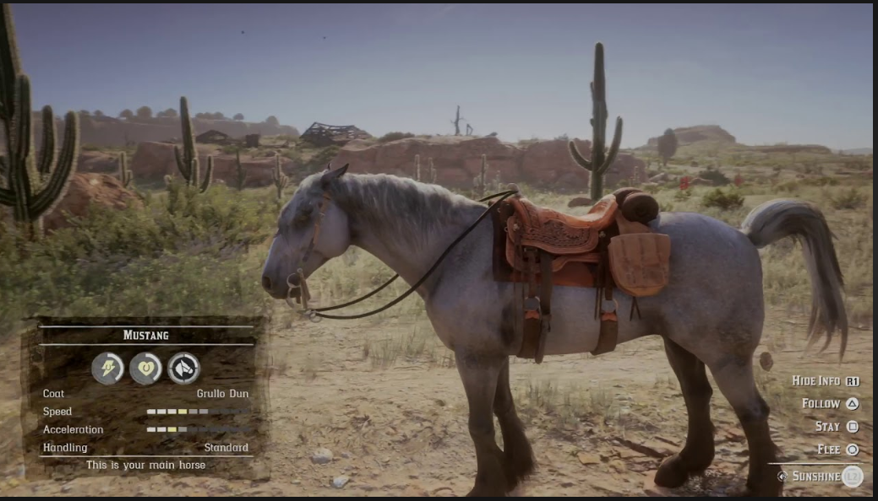

Horses will have three basic indicators: health, fitness, and trust with the owner.

* Blood will determine the health of the horse.
* Physical strength: will determine the speed of the fishing.
* Reliability: the higher this means that when you whistle even far away, the horse will follow.

# MAJOR CHARACTER IN STORY

In the game, the player's character is a gang member in the far west, the player will admire the beauty of this land with this character. Besides, you also experience the story along with each other NPC throughout the script.

# GAME LEVEL

|  |  |  |  |
| --- | --- | --- | --- |
| Level | Nhiệm vụ | Chương | Mô tả |
| LEVEL 0: | "Outlaws from the West" | Colter | After a failed robbery, the gang have fled from Blackwater into the Grizzly Mountains, but a late spring storm has left them half frozen and starving. They hole up in an abandoned mining town to lick their wounds and await a break in the weather. |
| LEVEL 1: | "Enter, Pursued by a Memory" |
| LEVEL 2: | "The Aftermath of Genesis" |
| LEVEL 3: | "Who the Hell is Leviticus Cornwall?" |
| LEVEL 4: | "Eastward Bound" |
| LEVEL 5: | "Who is Not Without Sin" | Horseshoe Overlook | After a break in the weather, the gang have headed down from the mountains, and are now hiding at Horseshoe Overlook. |
| LEVEL 6: | "A Strange Kindness" |
| LEVEL 7: | "Exit Pursued by a Bruised Ego" |
| LEVEL 8: | "The Spines of America" |
| LEVEL 9: | "The Sheep and the Goats" |
| LEVEL 10: | "A Strange Kindness" |
| LEVEL 11: | "Polite Society, Valentine Style" |
| LEVEL 12: | "Good, Honest, Snake Oil" |
| LEVEL 13: | "Pouring Forth Oil I" |
| LEVEL 14: | "Pouring Forth Oil II" |
| LEVEL 15: | "Further Questions of Female Suffrage" | Clemens Point | The gang got run of Valentine after an altercation with the railway magnate, Leviticus Cornwall, who has grown tired of having his trains robbed by gangs of outlaws. Afraid that the routes westwards were being watched by Pinkerton agents, the gang moved south and east and are now hiding at Clemens Cove, near the town of Rhodes. |
| LEVEL 16: | "Friends in Very Low Places" |
| LEVEL 17: | "A Short Walk in a Pretty Town" |
| LEVEL 18: | "Blood Feuds, Ancient and Modern" |
| LEVEL 19: | "The Battle of Shady Belle" |
| LEVEL 20: | "The New South" |
| LEVEL 21: | "The Course of True Love I" |
| LEVEL 22: | "The Course of True Love II" |
| LEVEL 23: | "The Course of True Love III" |
| LEVEL 24: | "The Course of True Love IV" |

# GAME PROGRESSION OUTLINE

The game consists of a plot until the Van gang disbands, after which Jonh and Sandie come to avenge Arthur. After completing the mission, Jonh returned and lived with his family. But here's more spinoffs. Jonh could not live peacefully when the new place still had other bandits that made him stand up for his family.

On one occasion Jonh was harmed and died, soon his wife also died of illness. Jonh's son is now an adult and decides to find the person who harmed his father. The story ends here.

# QUEST SYSTEM

The mission system is predetermined for each character if you want to take on the task, you need to meet with the NPC.

+ Chapter 1: Colter - After a failed robbery, the gang have fled from Blackwater into the Grizzly Mountains, but a late spring storm has left them half frozen and starving. They hole up in an abandoned mining town to lick their wounds and await a break in the weather.

+ Chapter 2: Horseshoe Overlook - After a break in the weather, the gang have headed down from the mountains, and are now hiding at Horseshoe Overlook.

+ Chapter 3: Clemens Point - The gang got run of Valentine after an altercation with the railway magnate, Leviticus Cornwall, who has grown tired of having his trains robbed by gangs of outlaws. Afraid that the routes westwards were being watched by Pinkerton agents, the gang moved south and east and are now hiding at Clemens Cove, near the town of Rhodes.

+ Chapter 4: Saint Denis - Things ended poorly in Rhodes. The Pinkertons showed up again, and little Jack Marston is kidnapped. The gang headed to Saint Denis hunting for Jack and are now hiding outside town, deep in the swamps, in a rundown old manor house called Shady Belle. Dutch is desperately searching for an escape plan for them all. Hosea meanwhile is hunting a serious score for them.

+ Chapter 5: Guarma - The bank robbery in Saint Denis was a disaster. The gang has been almost destroyed, several members were killed and arrested. Everything seemed lost. Dutch, Micah, Javier, Bill and Arthur escaped on a boat. The boat sank in the Carribean and they were washed ashore on the island of Guarma, a sugar cane producing island off the coast of Cuba. The island is dominated by Colonel Fussar, a local tyrant, kept in power by the sugar companies. The local workers are despondent. The gang, or what remains of them are pressured into helping by a Haitian smuggler named Hercule. In exchange, he will try to find them passage back to America.

+ Chapter 6: Beaver Hollow - The gang, or what is left of it were reunited at Lakay, but was quickly assaulted by a squad of Pinkertons. The gang fled into some dangerous county to the north and are now hiding in Beaver Hollow, awaiting their fate and riddled with internal disputes and anxieties. Arthur is not feeling very well and is unsure what to do.

# GENERAL ENEMY RULES

## Monsters

### Description

The shape can be as large or larger as the main play character with diverse races.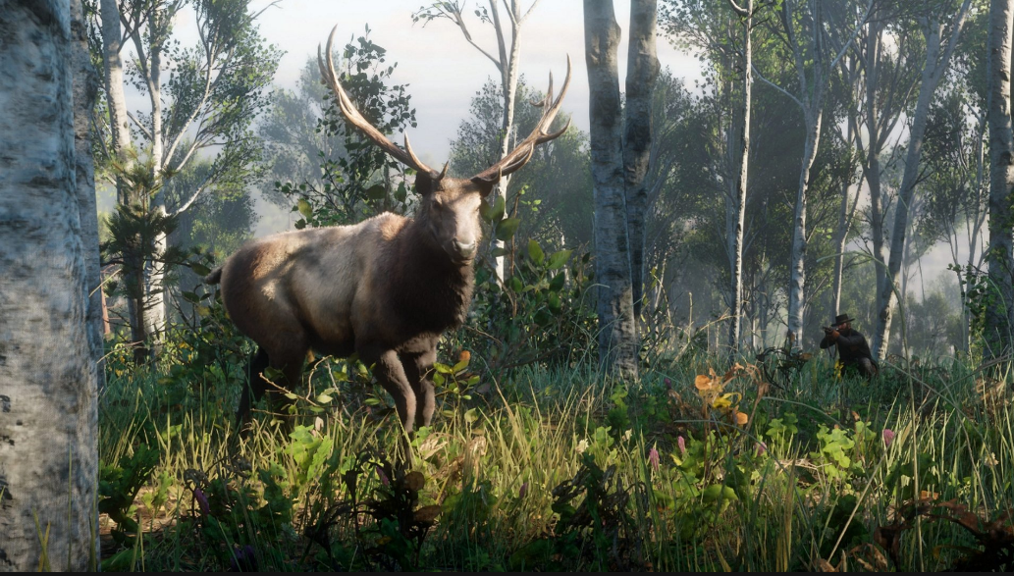

Big moose:

+ Attack power: 100

+ how to destroy: Use a shotgun when the ability to cause damage is high.

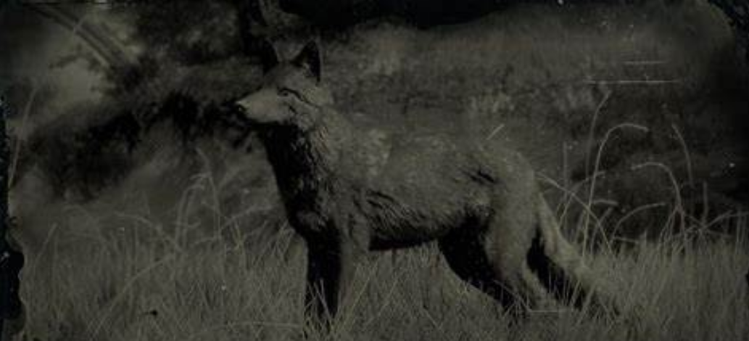

Wolf:

Attack power: 110

+ How to kill: Use a shotgun sometimes the ability to cause damage is high.

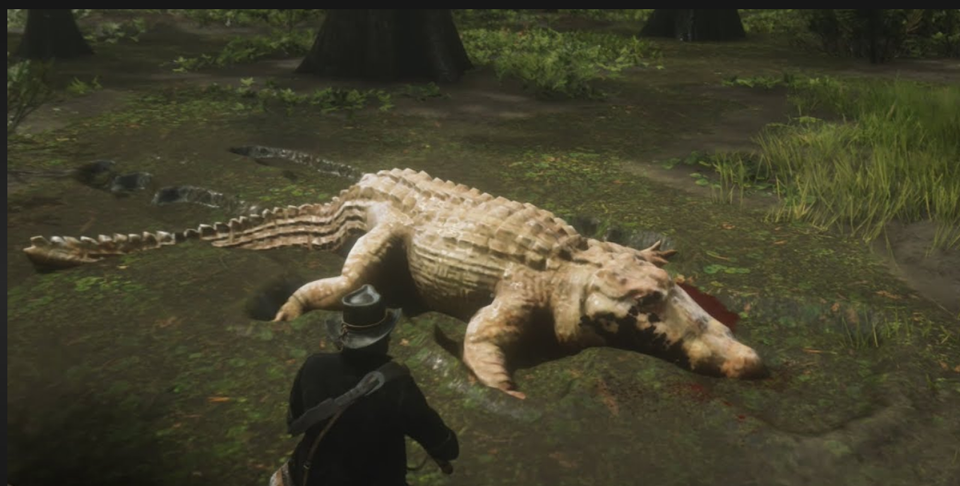

Crocodile

+ Attack power: 120

+ how to destroy: Use a shotgun when the ability to cause damage is high.

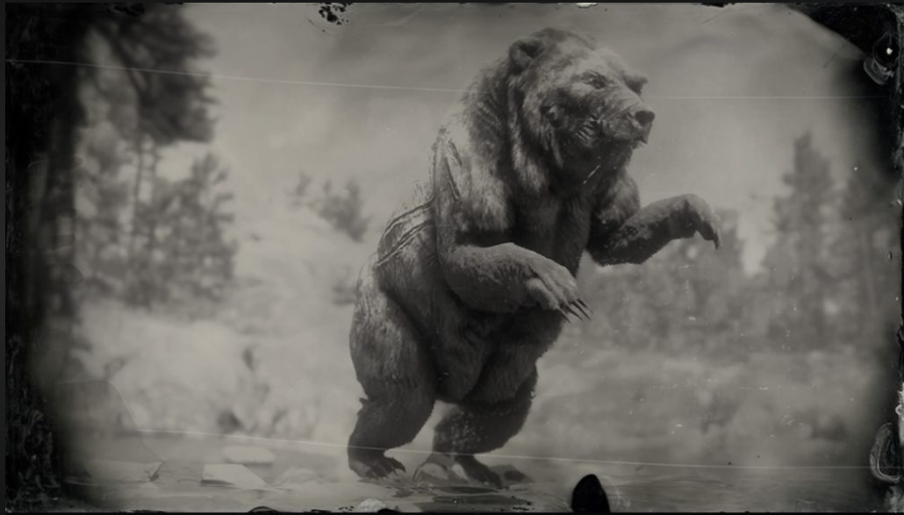

Bear:

+ Attack power: 115 - 120

+ how to destroy: Use a shotgun when the ability to cause damage is high.

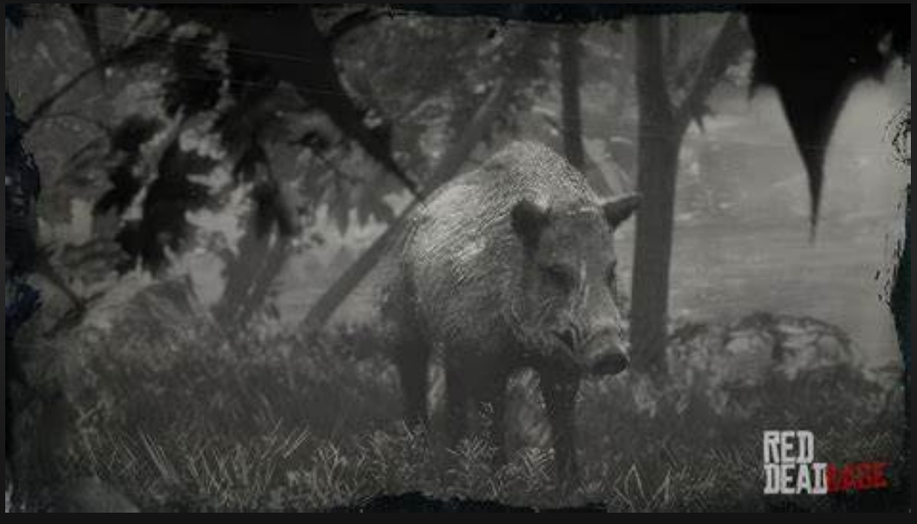

Wild boar:

+ Attack power: 90

+ how to destroy: Use a shotgun when the ability to cause damage is high.

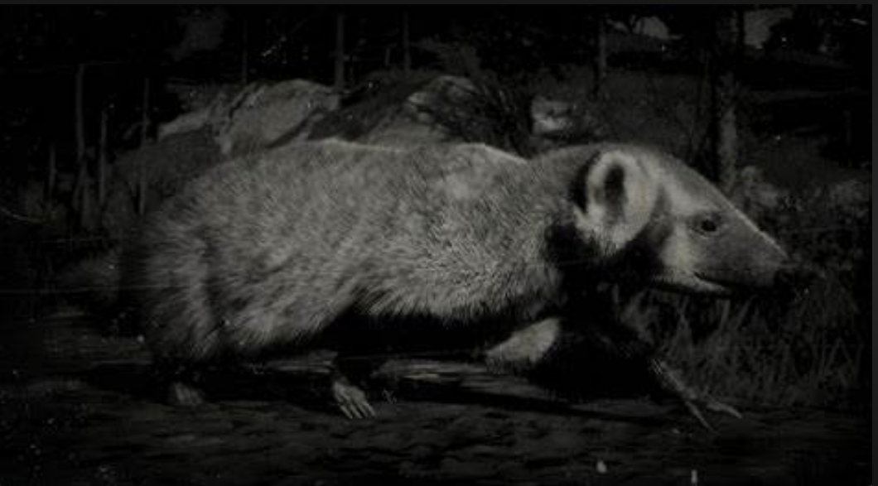

Rat:

Attacking power: 25-35

+ how to destroy: Use a shotgun when the ability to cause damage is high.

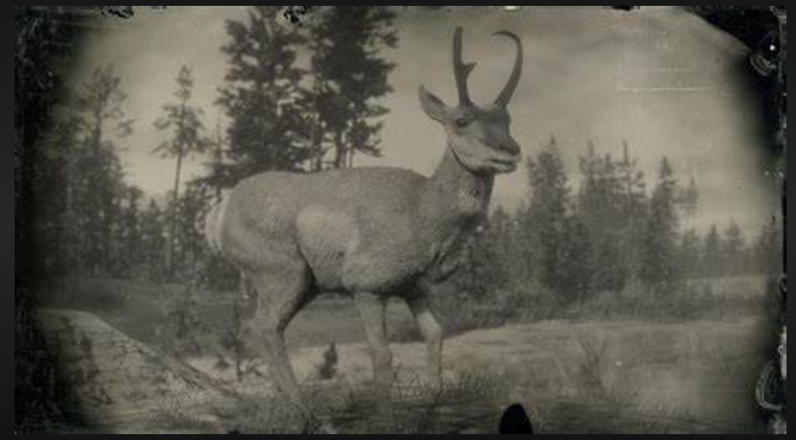

Deer:

Attacking power: 35-50

+ how to destroy: Use a shotgun when the ability to cause damage is high.

# BOSS

## Description

Bosses are legendary animals, extremely large in size, their skin can sell a lot of money, in addition, you can make equipment ...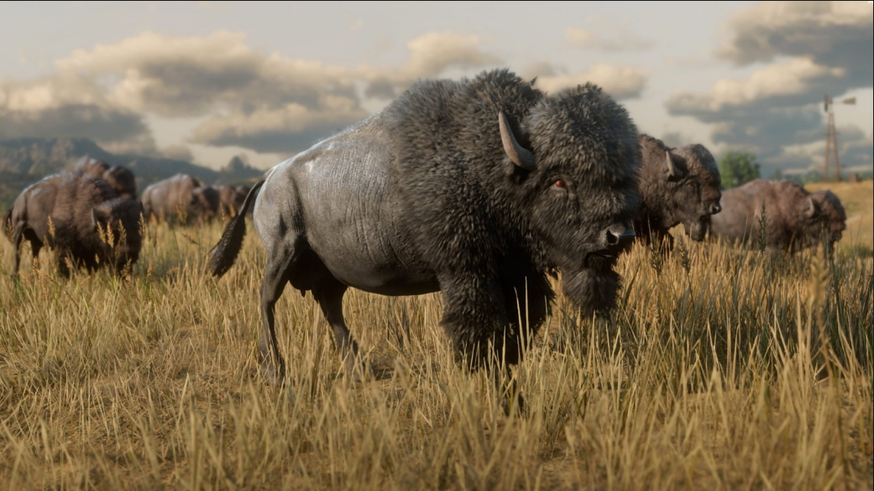

## 2. Ability

Use a majestic appearance to overwhelm the legendary animal character that can kill the character in the game

## 3. How to destroy

Relying on your own strength through skills and equipping a high-powered gun will help to destroy faster.

# NPC

## Description

NPC will be the characters in the game, will be the one who assigns you the task, when you complete the task will be rewarded by this character. Or in the tasks you will have to defeat these npcs.

-        NPC sales: These characters will buy back the things you sell, and resell you the necessary necessities.

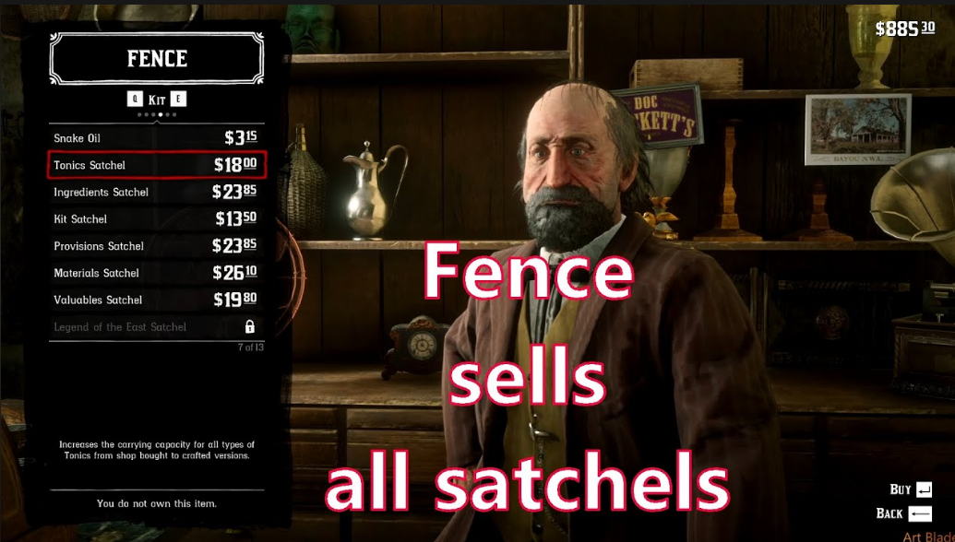

NPC task: These characters will assign tasks to you and when you complete them there will be rewards.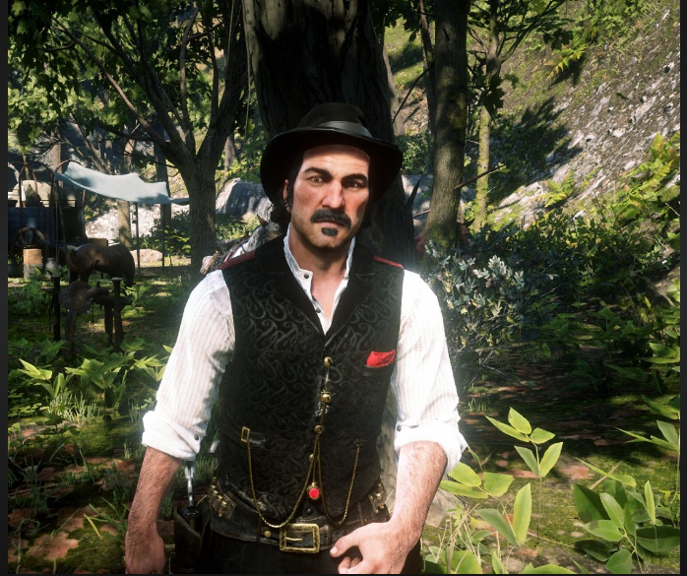

# COLLECTIBLES/OBJECTS SETS

In all levels, after completing the task, players will receive the corresponding items, gold, money depending on the difficulty of the mission.

To pick up rare items, the character needs to defeat the legendary beasts will have legendary items such as fur, skin.

# MUSIC AND SFX

Sound effects are an important, indispensable part of any game. It contributes greatly to the effect as well as showing the nature of the whole game and in each scene.

The whole game will have a dominant music song, but in each game scene, when light, slow, when fiercely tough, the music will change the appropriate variation, when it is easy, when rushing fiercely.

In each move, when the player uses any old gas, there will be a characteristic noise of that weapon. It's accompanied by effects sounds that make the player really attracted.